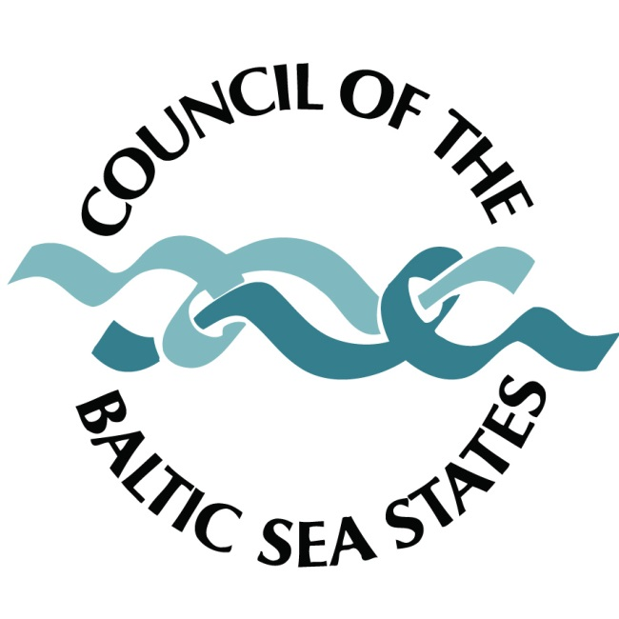

CBSS Expert Group EGSD/ 10/ 9.3/ Annex 9
Sustainable Development – Baltic 21
10th meeting
Turku, Finland

Agenda item 9.3: Introduction of the EUSBSR EU Seed money facility projects implemented under Horizontal Action ‘Sustainable’.

The Secretariat and representatives of the relevant projects that received funding after the second call from the EU Seed money facility will provide a presentation on the individual projects.

Experts are kindly asked to take note of the information provided and express their views on the potential involvement of suitable organizations from their countries to the project activities as well as suitable funding sources from structural fund programmes.

1. BALLOON – Low Carbon Emission Policy designing and implementing

Transition to a low carbon economy is one of the EU2020 strategy priorities within the framework of climate change and energy sustainability. The BALLOON main project aims to support the development of a low carbon economy in the Baltic Sea Region countries by establishing cooperation, building capacity and exchanging best practices among involved stakeholders. The project activities include networking, exchange of information, as well as developing methodologies and research instruments to promote the BSR as a low carbon growth region. The project also aims at building a platform to support the exchange of experience and networking activities.

Seed money project partnership
- Ministry of Environmental Protection and Regional Development (LV)
- Demos Helsinki (FI)
- Vytautas Magnus University Department of Environmental Science (LT)

Seed money project’s total budget: 31,200.00 EUR

Contact: Ms Elina Lice; tel: +371 6702 6908; email: elina.lice@varam.gov.lv

2. ClimUrban - Climate Change Adaptation for Sustainable Urban Development

In the last years climate change adaptation has become an increasingly important topic on the agenda of national and European climate policy. While the most of decisions are made at the national level there is still a lack of adaptation strategies and policies for the local and regional actions. The planned project will act as a catalyst to speed up local adaptation process around the Baltic Sea in order to better prepare regions for potential climate change impacts.

The goal of the main project is to support cities in the BSR region to develop appropriate climate change adaptation strategies – and potentially see towards their implementation. The main focus of adaptation shall lie on taking current and future flood hazards stronger into account in planning processes. Major issues of concern are, e.g., floods caused by storm waters, groundwater flooding, as well as riverine and marine flooding. By addressing groundwater floods the project also addresses groundwater quality and availability, which is a very important issue in the Baltic Sea Region.

Seed money project partnership
- Baltic Environmental Forum Germany (DE)
- Geological Survey of Finland (FI)
- Union of the Baltic Cities, Commission on Environment c/o City of Turku (FI)
- Nordregio (SE)
- The City of Pori, Technical Service Centre (FI)

Seed money project’s total budget: 49,698.00 EUR

Contact: Mr Matthias Grätz; tel: + 49 040 5330 7076; matthias.graetz@bef-de.org

3. The Baltic Sea Project - increasing science skills and awareness of sustainable development (BSP - Science Skills)

The main project aims to unite ideas, capacities and tools to improve education for sustainable development and strengthen transnational networks based on local and regional educational actions at the Baltic Sea Region. Drawn upon previous experience (the BSP was established in 1989) the main project is expected to create added value for already existing cooperation and to motivate various actors from educational sectors to work for a common purpose. A unique mobile app jointly developed by all participating countries will be the main outcome of the main project. The ‘Baltic Sea Project Learner’s Guide’ app aims to give new approaches for education and research and disseminate knowledge about sustainable development among students. An important aspect of the project will be awareness-raising among partners from different sectors and disciplines.

Seed money project partnership
- Tartu Environmental Education Centre (EE)
- St. Petersburg state university of economics (FINEC) (RU)
- Baltic Sea Project Sonderskov-Skolen (DK)
- Lithuanian Centre of Non-formal Youth Education (LT)
- Nacka Upper Secondary school (SE)
- National Centre for Education (LV)
- Baltic Sea Project Linnajoki school (secondary) (FI)
- Associated Schools Network of UNESCO Germany (DE)
- Konopnicka Secondary School Katowice – national coordinator of The Baltic Sea Project (PL)

Seed money project’s total budget: 44,831.00 EUR

Contact: Ms Kersti Sõgel; tel: +372 5598 3328; email: kersti.sogel@teec.ee

