POLISH STANDING CONFERENCE
ON THE INTERNATIONAL COOPERATION OF LOCAL SELF-GOVERNMENTS
2nd Session

Experiences and perspectives regarding the role of Polish local
SELF- governments in the strengthening of the local and regional dimension of the Eastern Partnership

POZNAŃ 28 JUNE 2013, Andersia Hotel,
opening: 10.00 a.m. (registration from 9.00 a.m.)

CONFERENCE PROGRAM
10.00 a.m. Inauguration of the conference:
Mr. Marek Woźniak – Marshal of the Wielkopolska Region, Chairman of the Polish Delegation
to the Committee of the Regions
10.15 a.m. Presentations by honorary guests
Mr. Štefan Füle – European Commissioner for Enlargement and Neighbourhood Policy: video message
Mr. Jerzy Pomianowski – Under-Secretary of State, Ministry of Foreign Affairs/Executive Director of the European Endowment for Democracy
Ms. Magdalena Młochowska – Under-Secretary of State, Ministry of Administration and Digitization
of the Republic of Poland
Presentation of the report:
Cooperation of Polish local self-government entities with regional and local authorities as well as other units from
Eastern Partnership states
Ms. Jolanta Taczyńska, PhD – Department of Commercial European Law, Faculty of Law and Administration, University of Lodz

10.45 a.m. PANEL I
LOCAL SELF-GOVERNMENTS AT A NEW STAGE OF THE EASTERN PARTNERSHIP
– concepts and possibilities of interregional cooperation

Speakers:
- Mr. Marek Woźniak – Marshal of the Wielkopolska Region, Chairman of the Polish delegation to CoR
- H.E. Jan Tadeusz Tombiński – EU Ambassador to Ukraine
- H.E. Staffan Herrström – Ambassador of Sweden to Poland
- Mr. Jerzy Pomianowski – Under-Secretary of State, MFA/Executive Director of EED
- Ms. Ewa Synowiec – Head of the European Commission Representation in Poland
- Mr. Roman Kuźniar, Prof. – Advisor to the President of the Republic of Poland

Debate moderator: Ms. Maria Przełomiec – Editor of the “Studio Wschód” (The East Studio) program on TVP Info
Time for debate
1.00 p.m. Coffee break /press conference

1.30 p.m. PANEL II
THE POLISH EXPERIENCE OF LOCAL SELF-GOVERNMENT FOR THE EASTERN PARTNERSHIP
COUNTRIES – the transfer of know-how. Opportunities and challenge for the future

Speakers:
- Mr. Filip Kaczmarek – Member of the European Parliament, Chairman of the EP delegation for relations with Belarus, Member of the EURONEST Parliamentary Assembly
- Ms. Karolina Zelent-Śmigrodzka - Deputy Director for Implementation of the Development Cooperation Department, Ministry of Foreign Affairs of the Republic of Poland
- Mr. Serhiy Tatusyak – Chairman of the Vinnitsa Regional Council
- Mr. Ugo Poli – Project Manager, Central European Initiative
- Mr. Andriy Fedoruk – Chairman of the Donetsk Regional Council
- Mr. Andrzej Porawski – Director of the Association of Polish Cities Bureau

Debate moderator: Ms. Małgorzata Nocuń – Deputy Editor-in-Chief of “New Eastern Europe”
Time for debate
around 3.00 p.m. Lunch
The conference will be held under the honorary patronage of

Mr. Radosław Sikorski, Minister of Foreign Affairs of the Republic of Poland
Ministry of Administration and Digitization of the Republic of Poland
The Conference of the Regional and Local Authorities for the Eastern Partnership

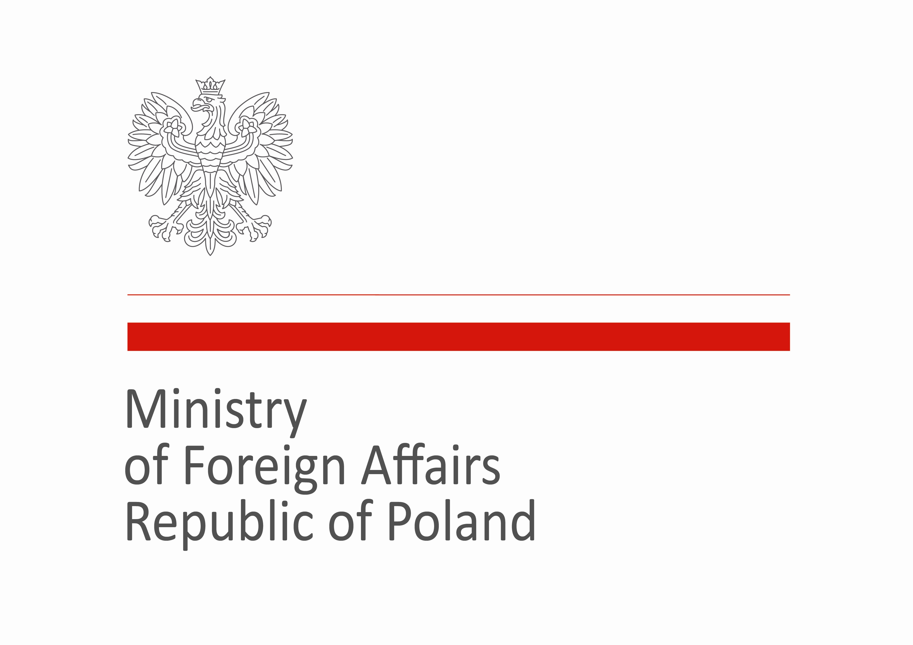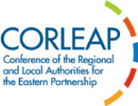
The project is co-financed by the Ministry of Foreign Affairs of the Republic of Poland

